KOALA Instructions
Check PyCharm Version
Make sure you are using the latest stable release of the IntelliJ IDE (version 2026.1 as of March 29, 2026)
To check this:
- Click on the to open the Main Menu
o On Mac, this will be in the top menu bar in PyCharm -> About
- Go to Help -> About to get the below pop-up:
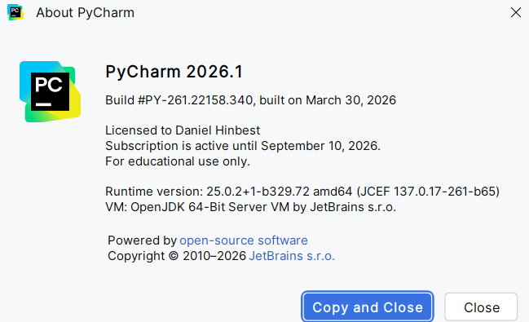
If it is not up-to-date, update your IntelliJ installation by doing the following: - Click on the to open the Main Menu
- Go to Help -> Check for Updates…
o On Mac, this will be on the top menu bar
If you receive the following pop-up on the bottom of your screen, your IntelliJ is already up-to date:
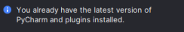
Installing KOALA
To install KOALA, go to the Google Drive link provided to you.
- Download the plugin’s zip file file and save it in a location where you can easily find it Open your course project in IntelliJ and install the plugin.
- If your PIN is even numbered, download koala-even.zip
- If your PIN is odd numbered, download koala-odd.zip
NOTE: Do not unzip the KOALA file.
- For Mac users, if Safari unzips it automatically
  - Go to Safari -> Settings -> General -> Uncheck “open safe files after download”
- Click on the icon and select Plugins… to open the Plugins menu - Click on the icon in the Plugins menu and select Install Plugin from Disk…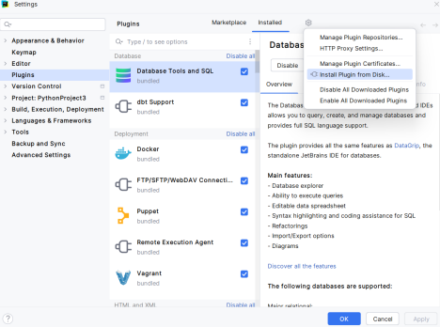
- Locate koala.zip in the file explorer and click OK
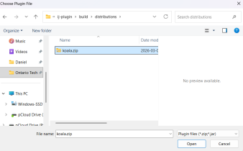
- Click Open, and Restart IDE on the Plugins window to install KOALA 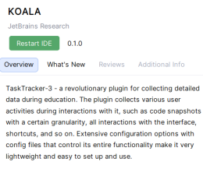
- After a few moments, you should receive a prompt to restart IntelliJ to complete the installation. Click Restart to proceed.
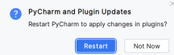
- After restarting, KOALA will be installed.
Using KOALA
Survey
Once KOALA is installed, it will be accessible on the right side of IntelliJ and can be found with this icon
Once you click on it, follow the instructions on the screen and on limeSurvey to complete this study.
Uninstalling KOALA
Once the tasks have been completed, you can uninstall KOALA.
- Click on the icon at the top of PyCharm and select Plugins… and switch to the Installed tab
You will see KOALA in the list of plugins
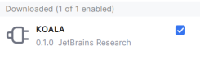
- On each of the plugins, click the and select Uninstall
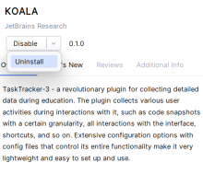
After the plugin has been uninstalled, click on Restart IDE and then Restart to complete the uninstallation process.
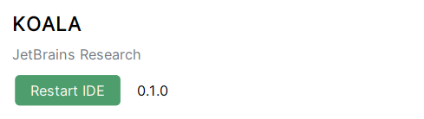
Click Restart to restart PyCharm. When it reloads, KOALA will be removed from PyCharm.
